Use the following template to know how to play our game.

- Game summary
The Player in level one is knowing how to play our game, he should collect the largest number of balls as much as he can. And, when he collects the first 10 balls he’ll turn to the next stronger & faster level. So, be that good player who’ll catch them all. And to be our perfect player you’ll have to get the prize too that will give you +5 score over what you have already took. And, if you lost three balls you will broke our heart and you will lose so the GAME OVER word will appear and you will be able to click at any place to RETURN to the starting page.


- Set up

- the materials in the game
Football

It’s Goal
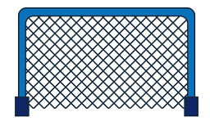
Basketball

And, it’s Basket
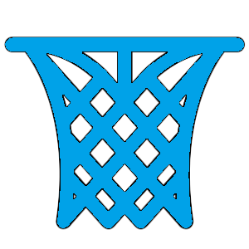
Carrots

Prize


- Explain where all of the parts of the game should be placed at the start of the game:
By default when you are going to start the game the football is the ball you are going to play with. But you are free to change the things you’re going to play with wither the basketball or the carrot from option page.

- The Winner
When you got all the balls in all levels while you are playing and you passed all the levels without throwing a ball outside the box then, CONGRATULATIONS YOU ARE THE PERFECT WINNER.



- The Loser
Unfortunately, every thrown ball outside the box one heart will die. So, when you throw 3 of our balls outside the box our 3 hearts will die and you will totally lose.
So be patient while you are playing.



